SECTION 8.5
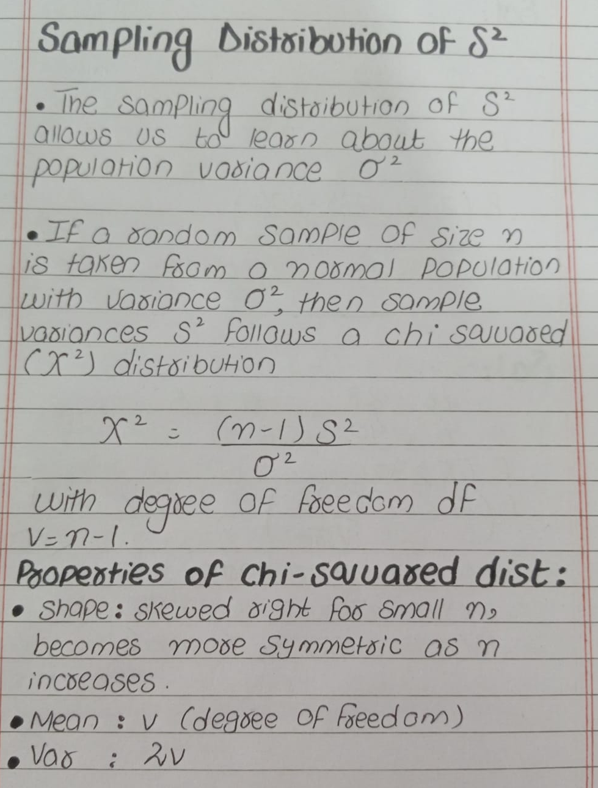
—----------------------------------------------------------------------------------------------------------------------------

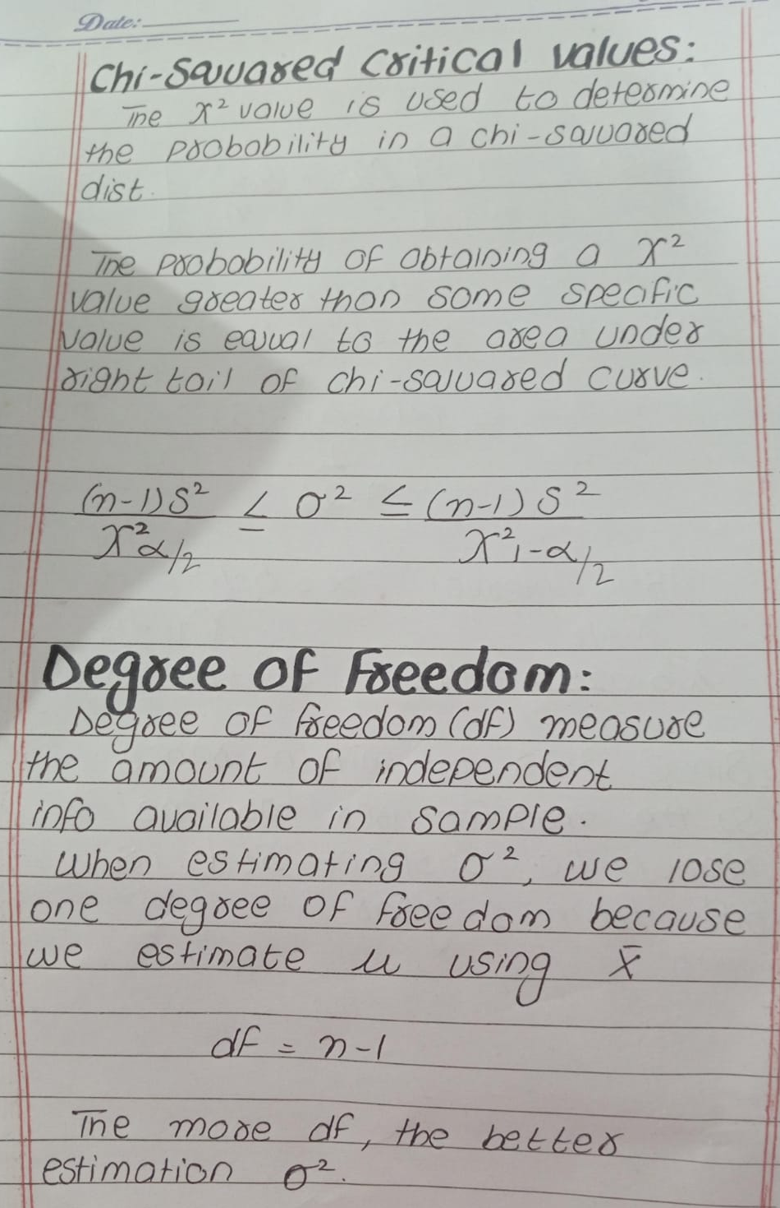Example 1: Car Battery Lifetime
Problem:
A manufacturer guarantees car batteries last on average 3 years with a standard deviation of 1 year.
A sample of 5 batteries has lifetimes: 1.9, 2.4, 3.0, 3.5, and 4.2 years.
Should the manufacturer still believe the standard deviation is 1 year?
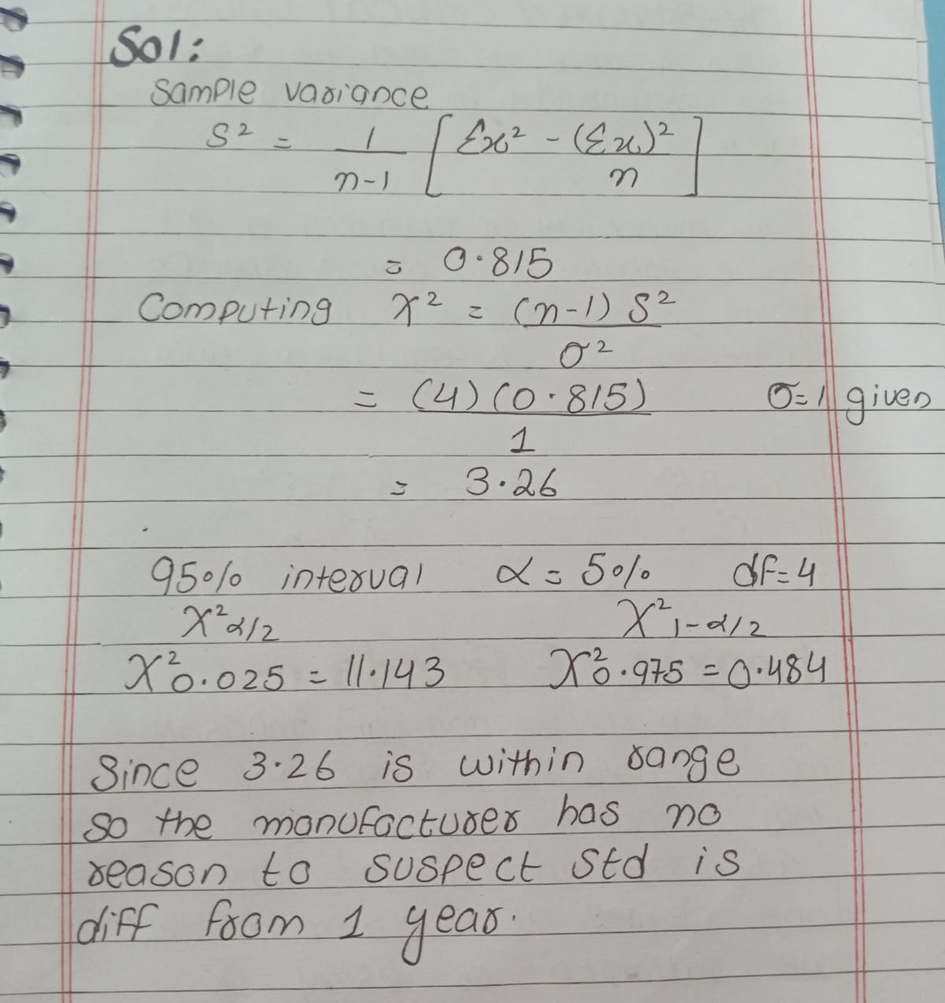
—----------------------------------------------------------------------------------------------------------------------------

Example 2: Hypothesis Testing for Variance
Problem:
A machine produces metal rods with an average diameter of 2 cm and a standard deviation of 0.1 cm.
A sample of 9 rods is taken, and the sample variance S² is 0.015 cm².
Can we conclude that the machine is still producing rods with a variance of 0.01 cm² at a 5% significance level?





